**Sentryc GmbH**

19-Aug-22

**Sentryc GmbH**

**QA – Coding Challenge**

**Roopali V**

**Test Case 1 - Check Login functionality by entering username and password**

The below code is written using Cypress and javascript.

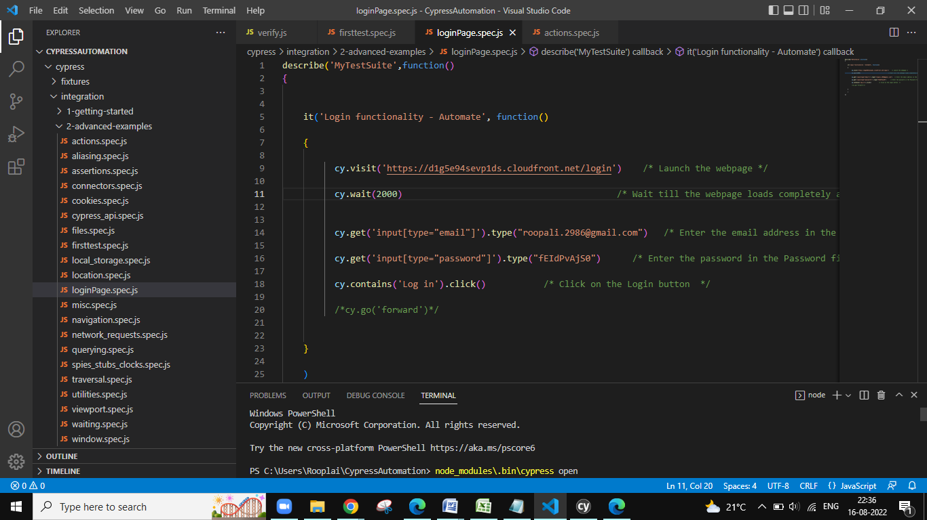

The below screenshot shows the step by step result. As we don’t have a valid login credential, the login was not successful. Hence the message “Wrong email or password” is being displayed.

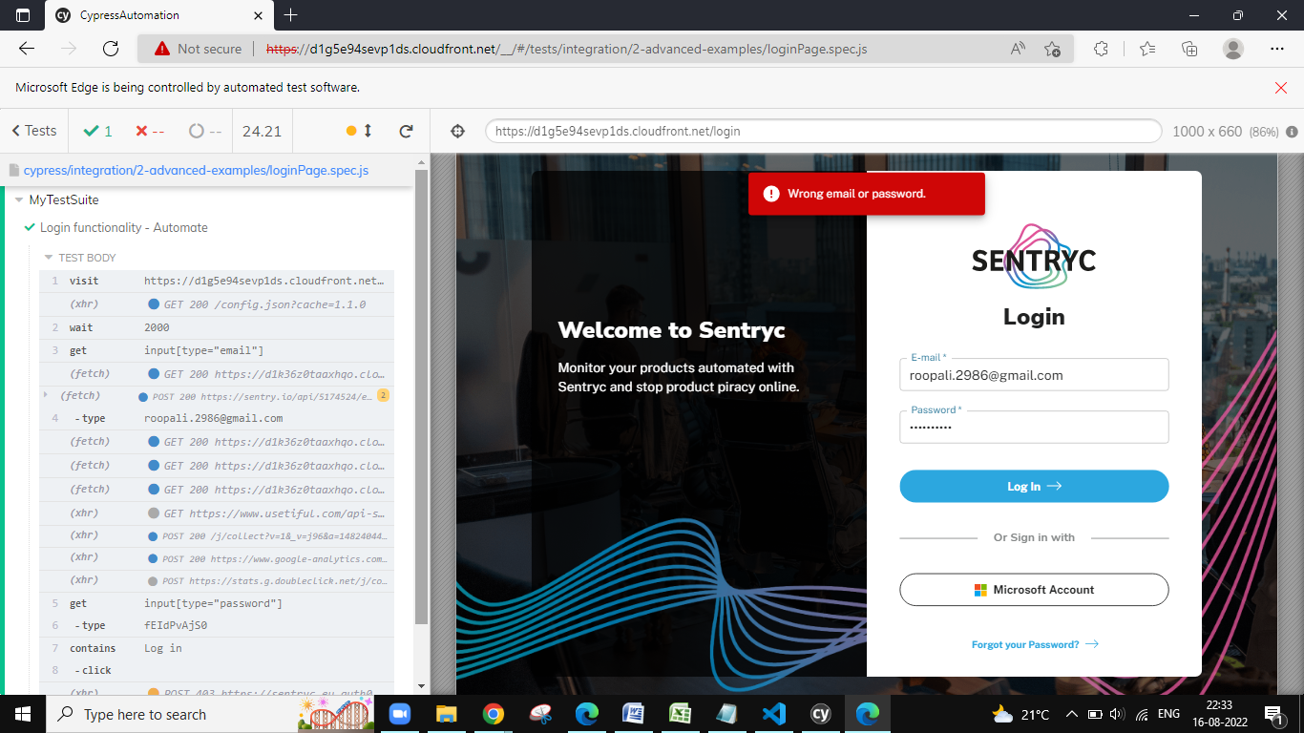

**Test Case 2 - Check Reset Password (Forgot your Password?) Functionality**

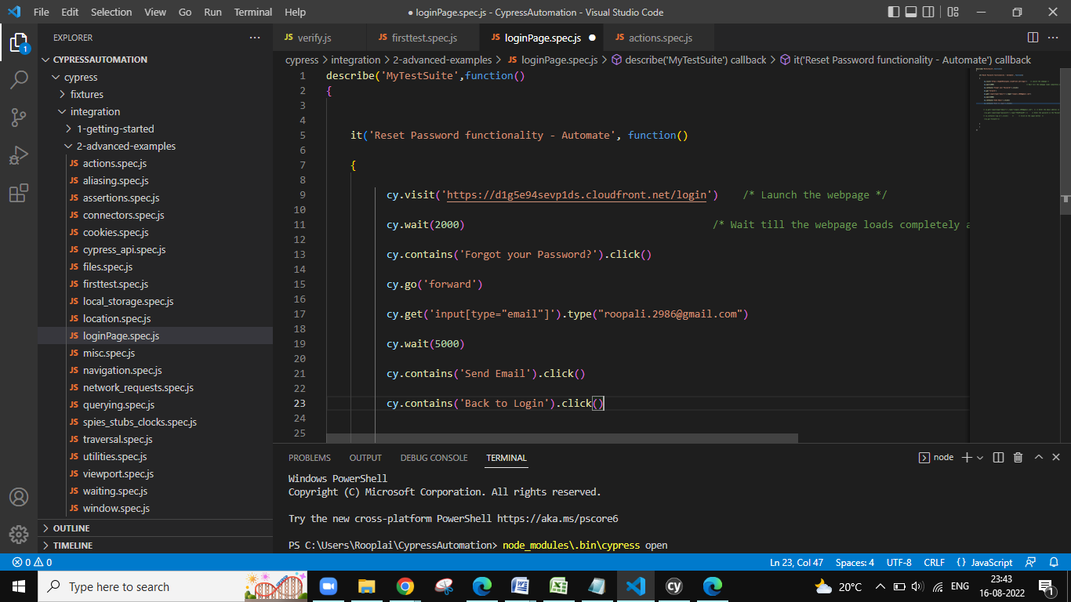

**Automation - Screenshots**

Launch the webpage

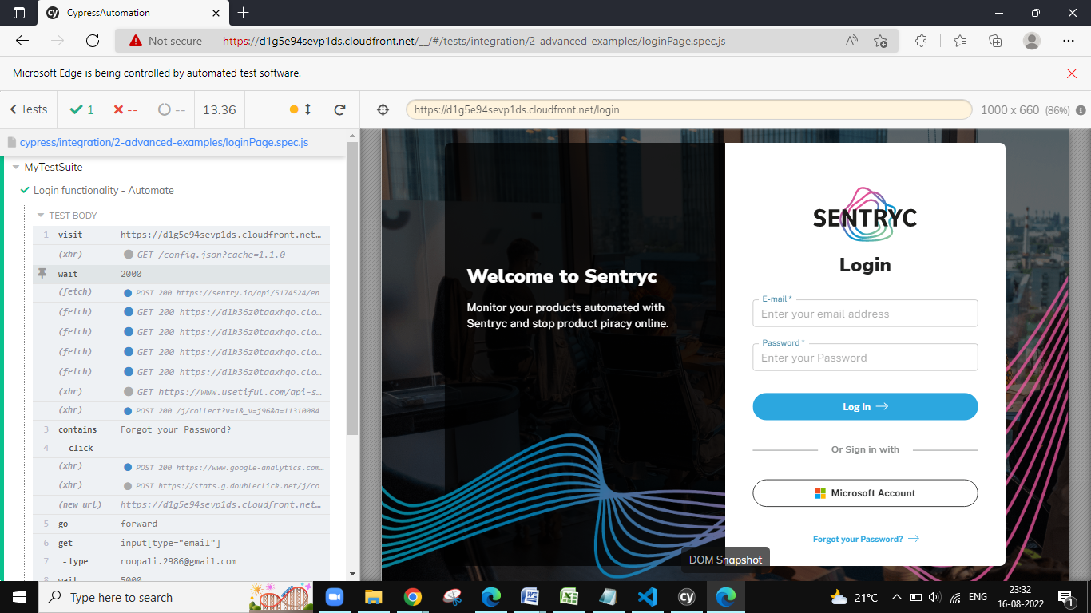

Click on the “Reset Password”

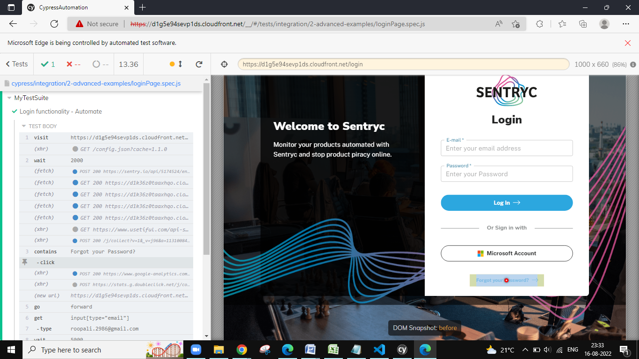

Navigate to the reset password page and enter the email address. Then click on the send email button.

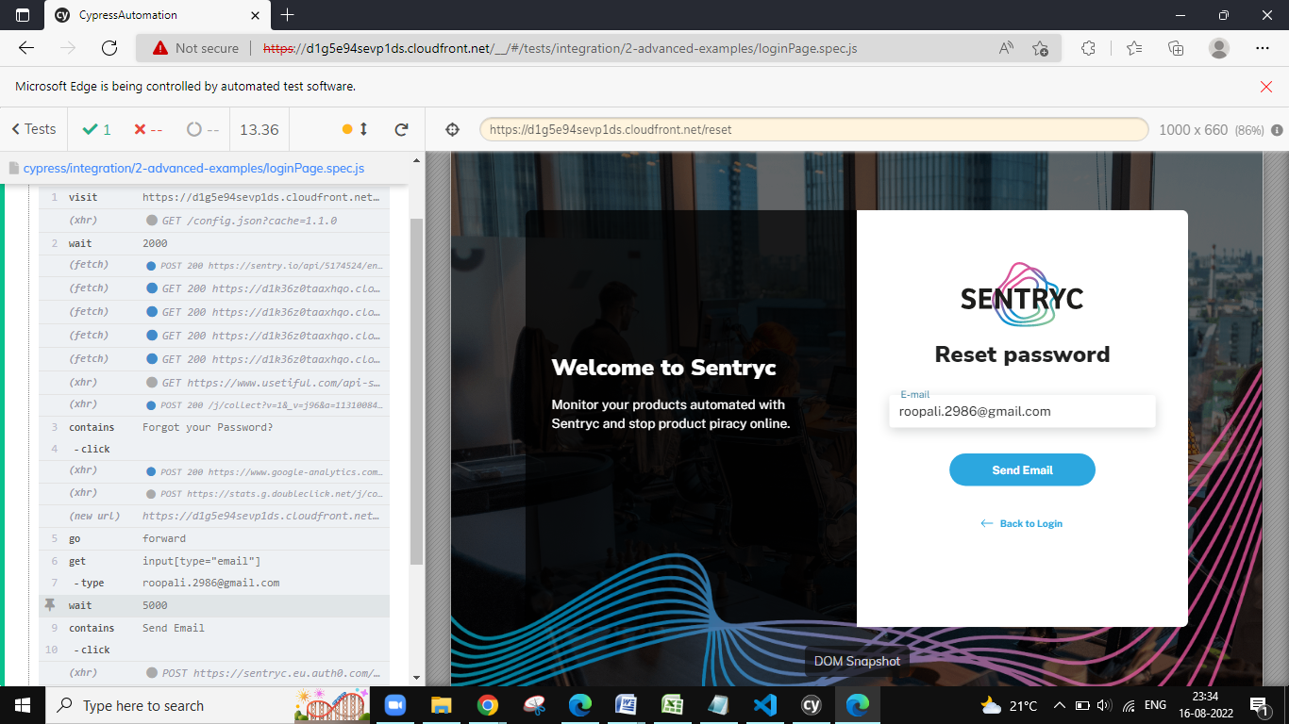

The message “We’ve just sent you an email to reset your password” is displayed.

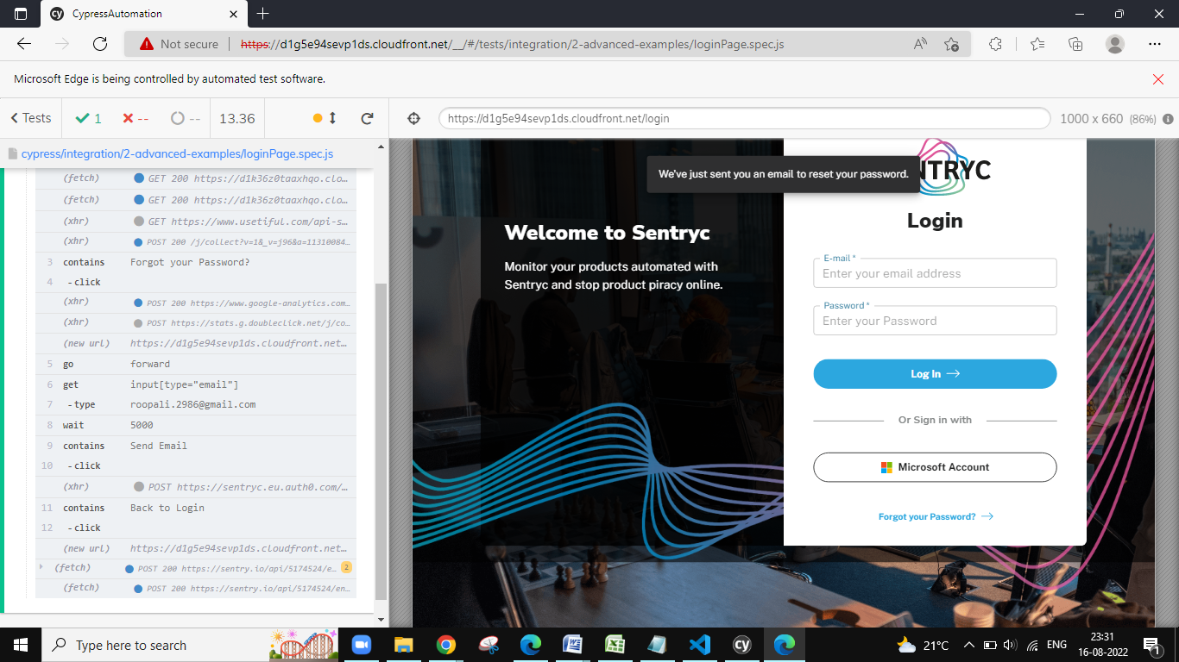

Later click on the “Back to Login”.

